PROJECT REPORT
ServiceNow Employee Raise Issue Portal
Employee Center • Custom Widget • Record Producer • Custom Issue Table

Project Details | Information
Platform | ServiceNow Employee Center
Instance | dev453028.service-now.com
Portal Path | /employee_request
Name | Sistu Aswija
Report Date | 12 October 2026

TABLE OF CONTENTS
- 1. INTRODUCTION —
- 1.1 Project Overview;
- 1.2 Purpose
- 2. IDEATION PHASE —
- 2.1 Problem Statement;
- 2.2 Empathy Map Canvas;
- 2.3 Brainstorming
- 3. REQUIREMENT ANALYSIS —
- 3.1 Customer Journey Map;
- 3.2 Solution Requirement;
- 3.3 Data Flow Diagram;
- 3.4 Technology Stack
- 4. PROJECT DESIGN —
- 4.1 Problem–Solution Fit;
- 4.2 Proposed Solution;
- 4.3 Solution Architecture
- 5. PROJECT PLANNING & SCHEDULING —
- 5.1 Project Planning
- 6. FUNCTIONAL AND PERFORMANCE TESTING —
- 6.1 Performance Testing
- 7. RESULTS —
- 7.1 Output Screenshots
- 8. ADVANTAGES & DISADVANTAGES
- 9. CONCLUSION
- 10. FUTURE SCOPE
- 11. APPENDIX —GitHub & Project Demo Link

1. INTRODUCTION
1.1 Project Overview
The ServiceNow Employee Raise Issue Portal is a portal-based issue reporting solution configured within ServiceNow Employee Center. It provides employees with a dedicated Raise an Issue entry point. Selecting Raise Ticket opens the Raise Employee Issue Record Producer, where the employee can enter issue information. The submission is stored in the custom Employee raises issues table and can be reviewed through the ServiceNow list view.
The portal homepage includes Quick Links (Password reset, System status, and Request Standing Desk), My Active Items, Recommended for You, My Favorites, Our Commercial Services, and a Raise an Issue banner. This report documents the observed project components and clearly distinguishes verified behaviour from features that still require testing.
1.2 Purpose
The purpose is to make employee issue reporting more organized by providing a consistent form and a central location for submitted records. It aims to reduce ambiguity in issue descriptions, support basic tracking through generated record numbers and state values, and provide a clear portal entry point for employees.
2. IDEATION PHASE
2.1 Problem Statement
Employees may need a simple and consistent way to report network, software, hardware, or access-related issues. Without a structured reporting form, issue details can be incomplete or difficult to review. The project addresses this problem by providing a single portal entry point and a Record Producer that captures standard issue fields and saves the submission in a ServiceNow custom table.
2.2 Empathy Map Canvas
The following empathy map is a design interpretation of the employee experience implied by the portal and form. It is not a survey result; no interviews or customer research data were provided.
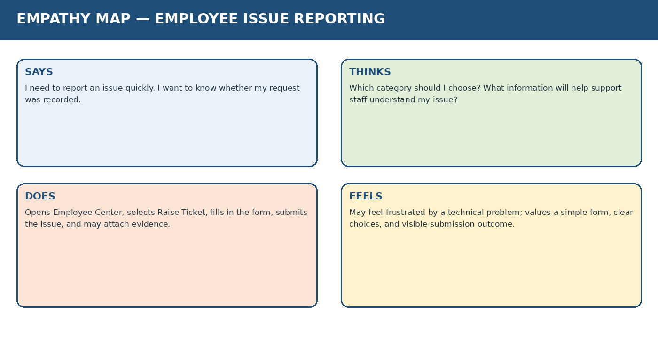
Figure 1. Empathy map for an employee reporting an issue.
2.3 Brainstorming
Idea | Benefit | Project fit
Single Raise Ticket entry point | Makes the reporting path easy to find | Implemented through the homepage banner and custom widget
Standard issue form | Captures consistent details | Implemented through the Raise Employee Issue Record Producer
Issue categories and subcategories | Helps classify employee requests | Choice fields are present in the form
Attachment area | Can provide supporting evidence | Visible in the form; end-to-end upload requires verification
Record list and generated number | Supports review and reference | Custom table list view is available
Automatic assignment and notifications | Could reduce manual follow-up | Future enhancement; not confirmed as implemented
3. REQUIREMENT ANALYSIS
3.1 Customer Journey Map
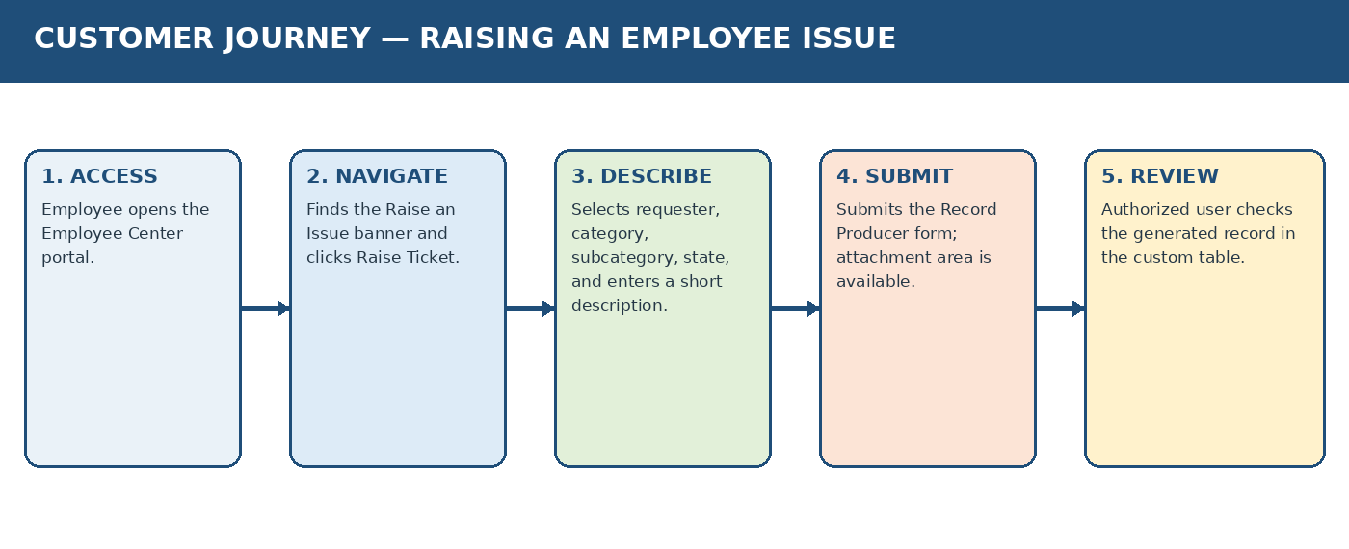
The journey map follows the observed user path from opening the portal to checking the created record. It represents the expected workflow and does not imply that every possible validation or attachment scenario has already been tested.
Figure 2. Customer journey for raising an employee issue.
3.2 Solution Requirement
Requirement | Description | Status based on evidence
Portal access | Employee can open the Employee Center homepage | Portal screenshot provided
Raise Ticket navigation | Button opens the issue Record Producer | Widget and form evidence provided; retest before final sign-off
Requester field | Form provides requester name reference variable | Visible in form and Record Producer configuration
Issue classification | Category and subcategory choices are available | Visible choices: Network, Software, Hardware, Access; VPN, Laptop, Server, Forgot password
Issue description | Employee can enter a short description | Field is present
Issue state | Employee can select a state value | Visible choices: New, In progress, Resolved, Closed
Record creation | Submission creates a custom-table record | List view shows saved records; verify each new test submission
Attachments | Form presents an attachment area | Persistence and permissions require testing
Access control | Only authorized users should access protected records | Roles and ACL rules not supplied; verify in instance
3.3 Data Flow Diagram
The diagram shows the logical data flow supported by the observed configuration. It excludes unverified external services, custom APIs, and automation.
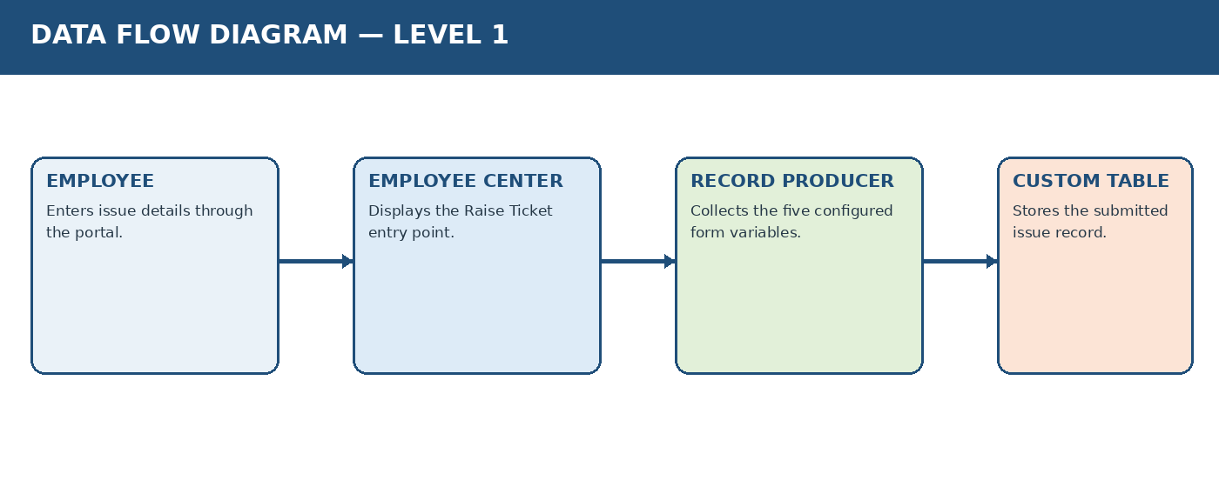
Figure 3. Logical data flow from employee input to the custom issue table.
3.4 Technology Stack
Layer | Technology / Component | Purpose
Platform | ServiceNow | Hosts the portal, Record Producer, widget, and table
User interface | ServiceNow Employee Center | Homepage and issue entry point
Navigation | Custom widget: link_redirect | HTML Template, CSS - SCSS, Client Script; opens the Record Producer
Form | Record Producer: Raise Employee Issue | Collects five configured variables
Data storage | Custom table: Employee raises issues | Stores submitted issue records
Browser access | Web browser | Used to access the development instance
External database / API | Not identified in supplied evidence | No separate database or custom REST API is documented
4. PROJECT DESIGN
4.1 Problem–Solution Fit
Customer need / problem | Project response | Evidence / limitation
Need an easy-to-find reporting entry point | Raise an Issue banner and Raise Ticket button | Visible on actual homepage
Need consistent issue details | Record Producer with requester, category, subcategory, short description, and state | Actual form and configuration screenshots
Need to reference a submitted issue | Generated number and custom table list view | List screenshot shows EMP-style record numbers
Need to provide context or evidence | Attachment area on the form | Actual persistence needs validation
Need to know progress | State field offers New, In progress, Resolved, Closed | Choice field exists; automatic state transitions not verified
4.2 Proposed Solution
The proposed solution is a ServiceNow-native employee issue reporting portal. An employee opens Employee Center, selects Raise Ticket, completes the Raise Employee Issue form, and submits it. ServiceNow creates a record in the Employee raises issues table. Authorized users can inspect the record in the list view.
- Use the existing Employee Center homepage as the entry point.
- Use the link_redirect custom widget for navigation to the Record Producer.
- Use the Record Producer variables to capture standard issue details.
- Use the custom table list view to find and review saved submissions.
- Validate required fields, attachment handling, user permissions, and any desired assignment or notification rules before production use.

4.3 Solution Architecture

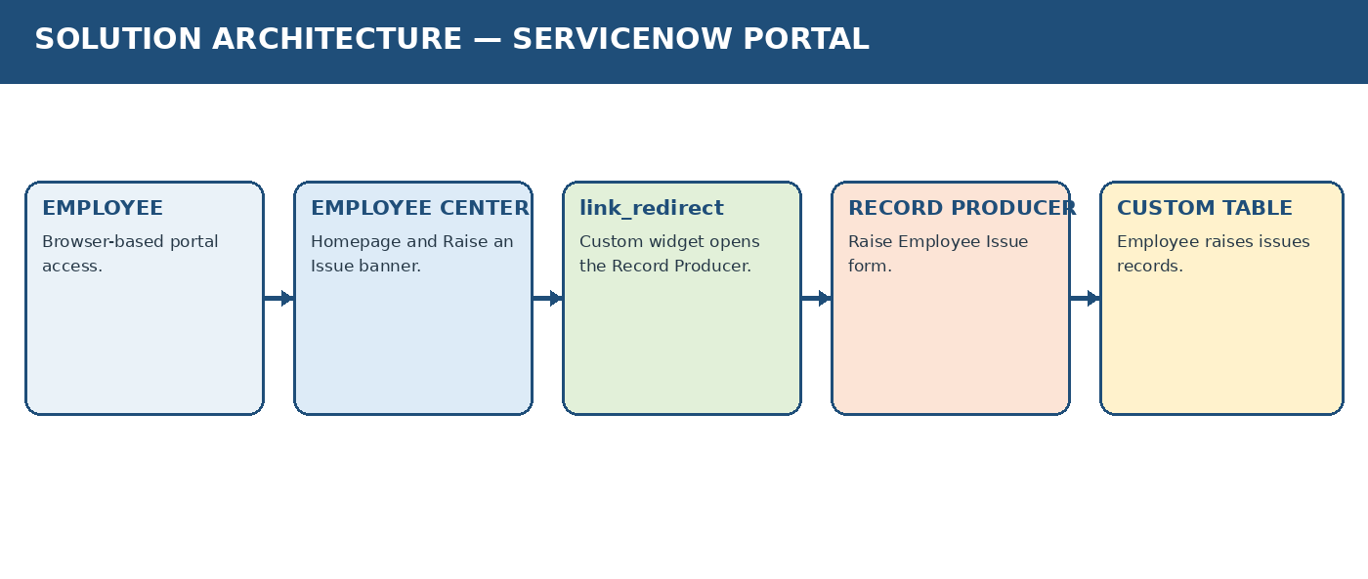
Figure 4. Solution architecture based on the supplied instance evidence.
The custom widget editor screenshot shows HTML Template, CSS - SCSS, and Client Script. The visible client-side function calls openRecordProducer() and uses a configured Record Producer identifier. A Server Script is not confirmed as enabled, so it is not included as an active component in the architecture.

5. PROJECT PLANNING & SCHEDULING
5.1 Project Planning
The following is a proposed planning breakdown for documenting and validating the existing project. Story points use the Fibonacci-style scale (1, 2, 3, 5) from the supplied planning reference. These are planning estimates, not a claim that the work was completed in these exact sprints.
Sprint | Work item | Estimated points
Sprint 1 — Core setup | Review portal and requirements | 3
Sprint 1 — Core setup | Verify custom table and fields | 5
Sprint 1 — Core setup | Review Record Producer and variables | 5
Sprint 2 — Integration | Verify Raise Ticket widget navigation | 3
Sprint 2 — Integration | Check form choices and validation | 5
Sprint 2 — Integration | Run end-to-end submission tests | 5
Sprint 3 — Finalization | Capture output evidence | 2
Sprint 3 — Finalization | Prepare report and diagrams | 3
Sprint 3 — Finalization | Final review and sign-off checklist | 2
Estimated total: 33 story points. This is a proposed estimate only; no actual completed sprint totals or team velocity were supplied. Velocity should be calculated from completed story points divided by the number of completed sprints.
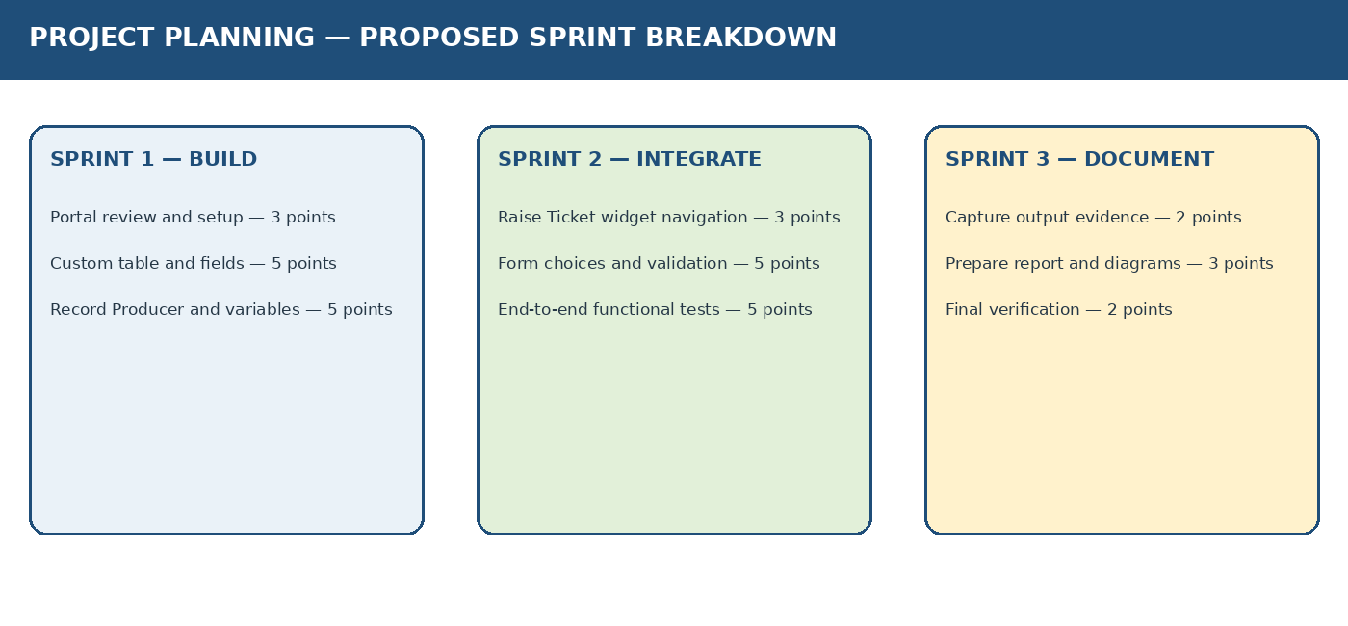
Figure 5. Proposed sprint grouping for final verification and documentation.
6. FUNCTIONAL AND PERFORMANCE TESTING
6.1 Performance Testing
Functional testing should confirm that the portal opens, the Raise Ticket button navigates to the correct form, the fields are available, submissions create records, and records can be found in the custom table. Performance testing should measure page-load and submission response times under a defined test setup. No benchmark timings, load-test results, or automated performance test outputs were provided; therefore no numerical performance claims are made.
Test ID | Test scenario | Expected result | Evidence/status
FT-01 | Open Employee Center portal | Homepage loads for an authorized user | Homepage screenshot provided
FT-02 | Select Raise Ticket | Raise Employee Issue form opens | Previously demonstrated; retest before sign-off
FT-03 | Inspect form variables | Requester, category, subcategory, short description, and state appear | Form screenshot provided
FT-04 | Submit valid issue details | A new record is created | List contains records; retest a fresh submission
FT-05 | Search generated number | Submitted record is found in custom table | List screenshot provided
FT-06 | Try category/subcategory combinations | Selections match configured choices and intended dependency rules | Not recorded; test manually
FT-07 | Submit with required values missing | Validation behaves as configured | Not recorded
FT-08 | Attach a file and submit | Attachment remains linked to the issue | Not recorded
FT-09 | Check permissions with different users | Access follows configured roles and ACLs | Not recorded
PT-01 | Measure homepage load time | Record repeated timings under stated conditions | Not performed / no data supplied
PT-02 | Measure form submission response time | Record response timings for repeated submissions | Not performed / no data supplied
7. RESULTS
7.1 Output Screenshots
The following are screenshots supplied from the actual ServiceNow project instance. They are included as evidence of the portal, form, table, and configuration. Schematic diagrams elsewhere in the report are explicitly labelled as diagrams.

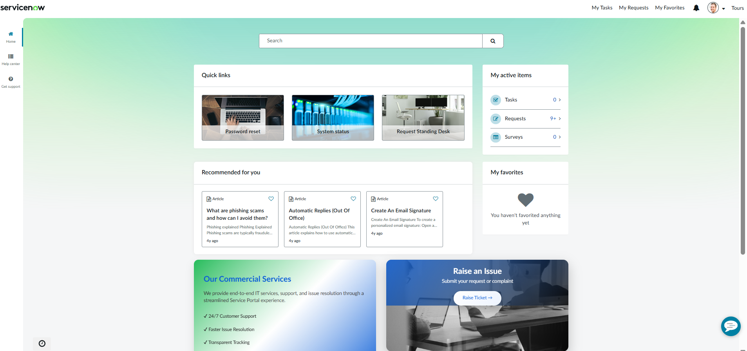

Figure 6. Actual Employee Center homepage.

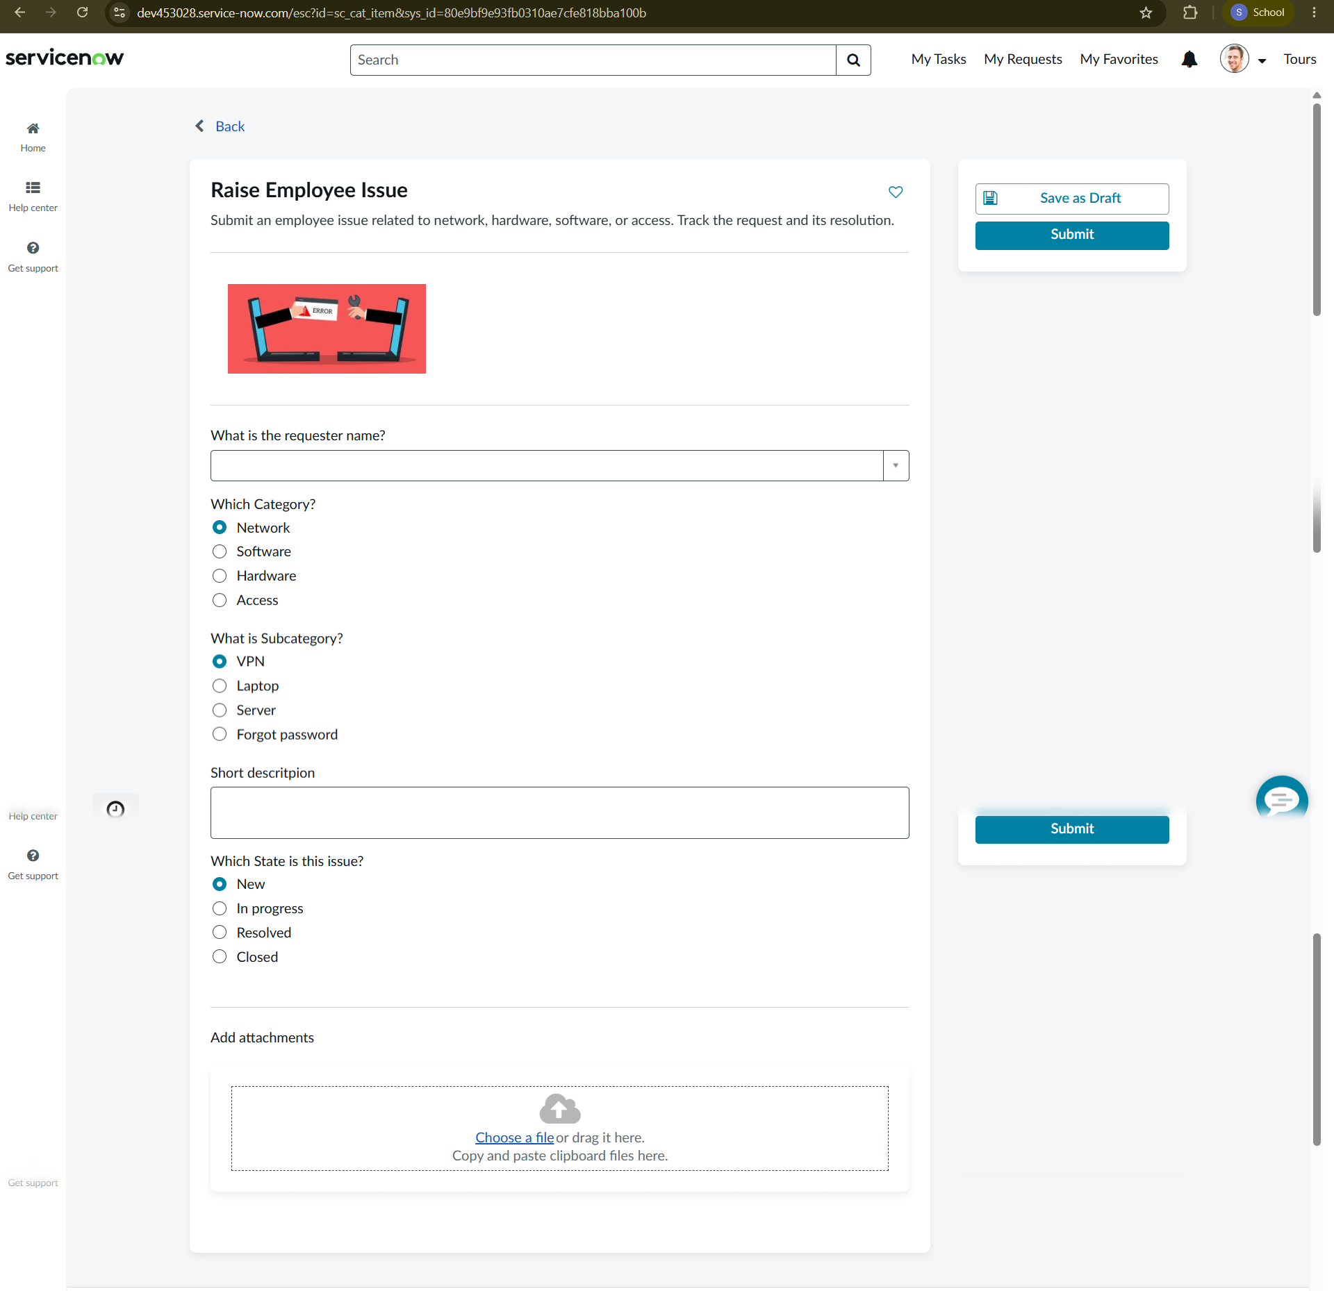
Figure 7. Actual Raise Employee Issue form.
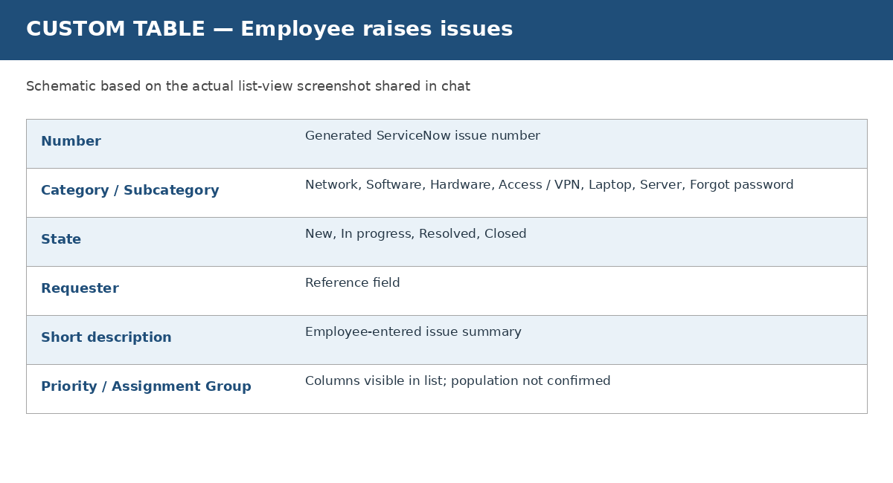
Figure 8. Schematic summary of the Employee raises issues table, based on the provided list screenshot.

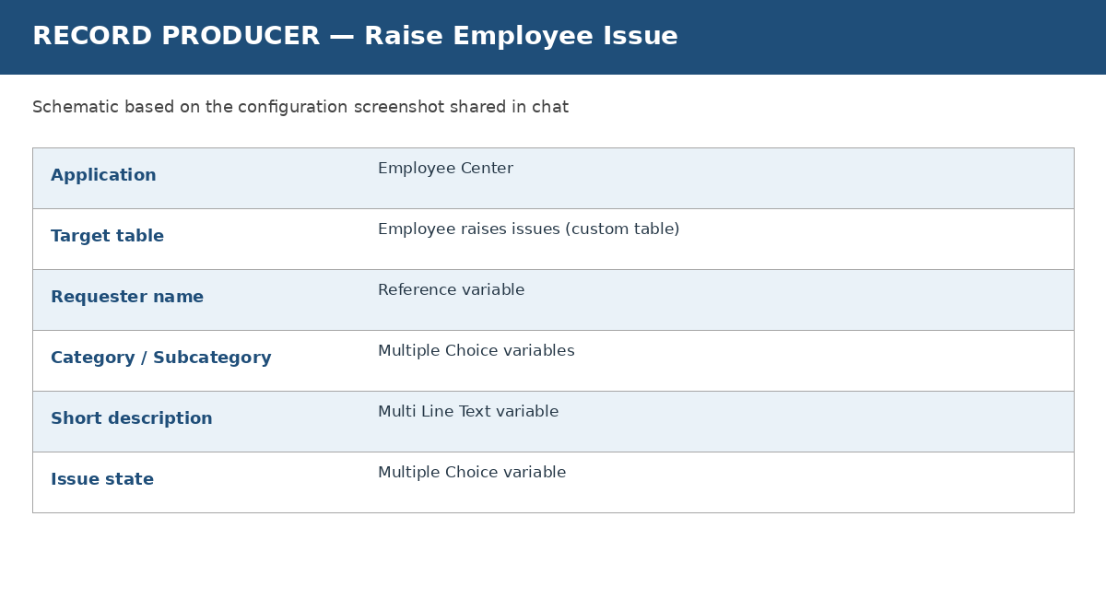
Figure 9. Schematic summary of the Raise Employee Issue Record Producer configuration.
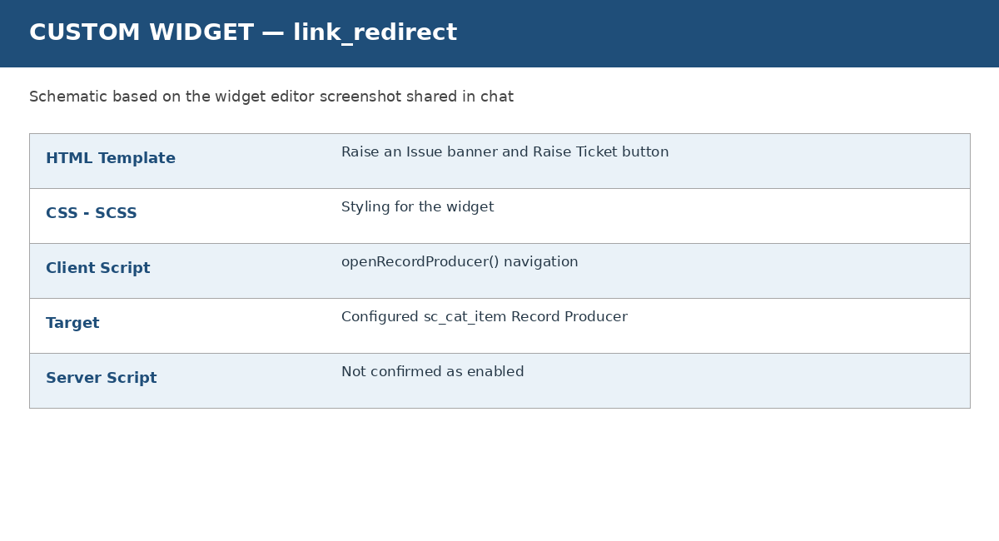
Figure 10. Schematic summary of the link_redirect widget editor configuration.
Observed results: the homepage contains the Raise an Issue entry point; the form displays the five configured variables and attachment area; the Record Producer targets the custom issue table; and the table list displays generated record numbers and issue-related columns. A formal test log and measured performance results were not supplied.
8. ADVANTAGES & DISADVANTAGES
Advantages | Disadvantages / limitations
Single portal entry point for issue reporting | Requires access to the ServiceNow instance
Standard fields improve consistency of submitted information | Field validation and category-subcategory dependency need test confirmation
Generated record numbers support reference and search | Shown records include some empty requester/assignment values
Uses ServiceNow platform components instead of a separate application stack | Availability depends on the development instance
Attachment area can help employees provide supporting evidence | Attachment persistence and access permissions require verification
Can be extended with assignment, notifications, and reports | Those automations are not verified as currently implemented
9. CONCLUSION
The ServiceNow Employee Raise Issue Portal provides a structured portal-based flow for reporting employee issues. The observed implementation combines an Employee Center homepage, a custom link_redirect widget, the Raise Employee Issue Record Producer, and the Employee raises issues custom table. The supplied screenshots confirm the key user interface and configuration elements. Before production use, the project should be tested for required-field validation, attachment retention, access permissions, and any desired assignment or notification behaviour. Performance conclusions should be added only after measurements are collected.

10. FUTURE SCOPE
- Configure and test category-to-subcategory dependencies where required.
- Add assignment rules to route issues to the correct support group.
- Configure submission acknowledgements and status-change notifications.
- Define priority rules and service-level targets if required by the organization.
- Improve validation messages and clearly mark mandatory fields.
- Test attachment upload, retention, and authorization end to end.
- Create reports or dashboards for issue category, state, and resolution trends.
- Add documented role-based access tests and a formal UAT sign-off.
- Perform repeatable performance tests and record response times.
- Consider packaging/exporting the application and documenting source control if the project is to be shared or maintained by another team.

11. APPENDIX
11.1 Source Code (if any)
The implementation is configured in the ServiceNow instance. The provided widget screenshot shows the HTML Template, CSS - SCSS, and Client Script for link_redirect. A full source export or repository was not provided, so the complete application source is not reproduced here. The widget uses a click handler that calls c.openRecordProducer(); the client function searches for a sc_cat_item record using a configured Record Producer identifier.
11.2 Dataset Link
Not applicable based on the supplied evidence. The project does not show a separate machine-learning dataset or external dataset dependency. Issue data is stored as records in the ServiceNow custom table.
11.3 GitHub & Project Demo Link
Project demo / portal URL: https://dev453028.service-now.com/employee_request
GitHub repository: https://github.com/Aswi-05/Employee-Raise-Issue.git
11.4 Verified Configuration Summary
Item | Observed value
Instance host | dev453028.service-now.com
Portal path | /employee_request
Homepage page ID (from prior project context) | ec_standard_home
Custom widget | link_redirect
Record Producer | Raise Employee Issue
Application | Employee Center
Target table | Employee raises issues
Record Producer variables (5) | Requester name; Category; Subcategory; Short description; State
Categories shown | Network; Software; Hardware; Access
Subcategories shown | VPN; Laptop; Server; Forgot password
State choices shown | New; In progress; Resolved; Closed

